Effort falls continuously, from the day the tooling lands. Price steps down discretely, only when the contract comes up. Those are two different clocks, and I collapsed them into one axis, which destroyed the whole point. The ice cube is melting the entire time — the renewal is just when the bill catches up to the puddle. Renewal is the recognition event, not the melting event.
So revenue isn't a smooth ramp down. It's a step function, and effort is a ramp beneath it. The gap between them is margin the vendor harvests and then surrenders.
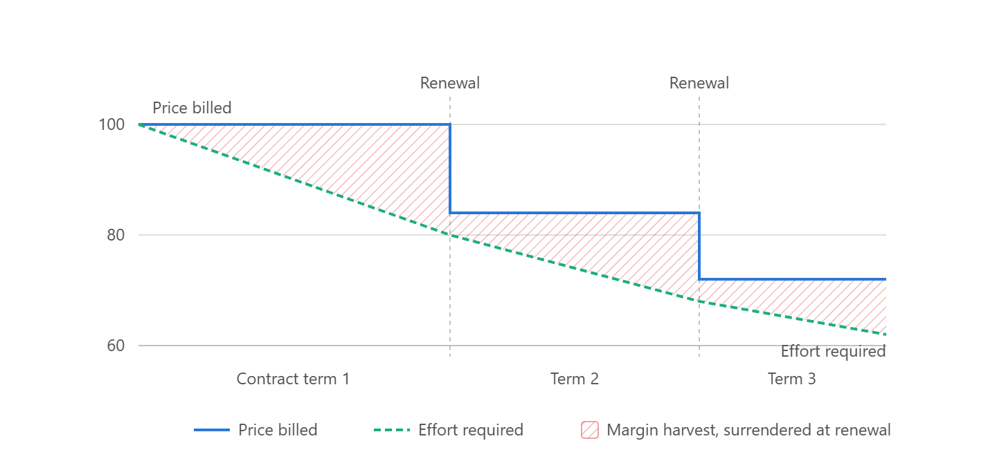
Now the sawtooth does the work. Within each term, price is flat while effort falls — the red wedge opens, and that's the vendor harvesting productivity. At renewal, price snaps down to meet effort, the wedge collapses to a normal margin, and the harvest starts again from a lower base. Revenue is a staircase down. Margin is a sawtooth.
Three things fall out of the correction that the wrong chart was actively hiding:
1. Contract duration is the central defensive variable — and neither of us was tracking it. The lag between the effort ramp and the price step is the weighted-average remaining life of the AMS book. A five-year book harvests for years before the cliff. An annually-repriced book has no harvest at all. This should be a Moats line in the scorecard, and it's the sort of thing you'd have to get from IR because nobody discloses WARL on the services book.
2. Expanding margins in an AMS-heavy book are a bearish signal, not a bullish one. The red wedge is the margin. It's widest immediately before the cliff. So a vendor reporting AI-driven margin expansion on effort-priced work is telling you the gap between what they bill and what the work costs has grown — which is precisely the gap the client will claw back at renewal. Margin expansion is the leading indicator of revenue deflation. Reported as a positive, it's the tell.
3. It reframes the melting-ice-cube tripwire. The test isn't "is revenue falling." It's "is margin expanding while TCV-to-revenue conversion deteriorates?" That pair, moving together, is the signature. Neither alone proves anything.

